HOUSE RENT APP USING MERN
Team details-
- Team ID: LTVIP2026TMIDS89471
- Team Size: 4
- Team Leader: Samudalapalepu Naveen
- Team Member: Koyyalagadda Venkata Rama Raju
- Team Member: Shaik Yasmin
- Team Member: Gunnammareddy Lakshmi Priyanka
- College Name: Vishnu Institute of Technology

INTRODUCTION
A Freelancing Platform is a web-based application designed to connect clients with skilled freelancers. SB Works enables clients to post projects and freelancers to bid on them based on their skills and expertise.
DESCRIPTION
The purpose of SB Works (FreelanceFinder) is to streamline the freelancing ecosystem by providing a secure, transparent, and user-friendly platform that connects clients, freelancers, and administrators.
- Empowering Freelancers:
SB Works allows freelancers to showcase portfolios, skills, and experience, helping them secure projects and build careers.
- Simplifying Project Hiring:
Clients can easily post projects, review proposals, compare freelancer profiles, and select suitable candidates.
- Facilitating Secure Collaboration:
Integrated chat system enables real-time communication and project discussion.
- Ensuring Transparency:
Proposal tracking (Applied, Shortlisted, Accepted, Rejected) ensures clear workflow visibility.
- Providing 24/7 Digital Access:
The platform is accessible anytime, allowing seamless project management.

FEATURES OF SB WORKS
1. Advanced Project Search
- Filter by skills, budget, category, and deadline
- Save preferred projects
2. Freelancer Profiles
- Portfolio uploads
- Skills and experience details
- Ratings and reviews
3. Real-Time Communication
- Secure chat system
- Project-specific discussions
4. Proposal & Status Tracking
- Freelancers can track proposal status
- Clients can review and shortlist proposals
5. Admin Monitoring
- User management
- Project monitoring
- Dispute resolution

TECHNICAL ARCHITECTURE
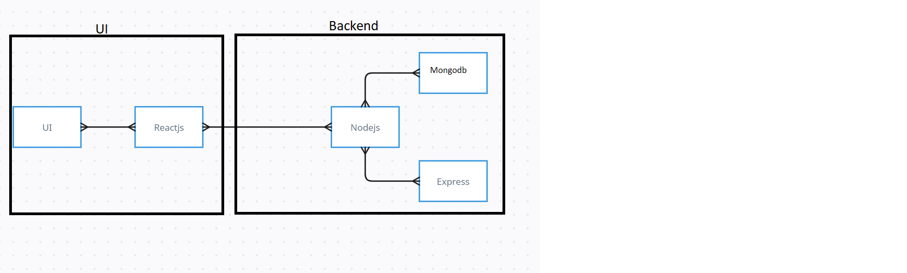
The technical architecture follows a client-server model.
Frontend:
- Built using React.js
- UI designed using Bootstrap & Material UI
- Axios used for API communication
Backend:
- Developed using Node.js & Express.js
- RESTful APIs handle client-server communication
- JWT used for authentication
Database:
- MongoDB for storing users, projects, proposals, and chat data
- Mongoose used for schema modeling
This architecture ensures scalability, real-time communication, and efficient data management.

ER DIAGRAM

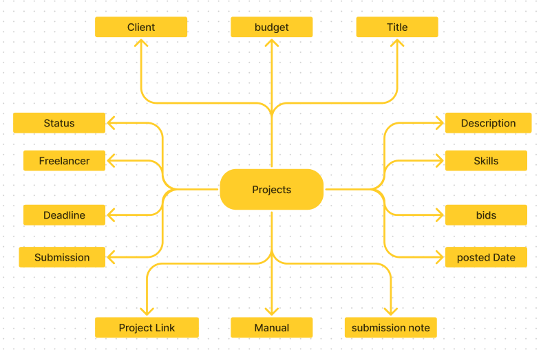

PREREQUISITE:
Here are the key prerequisites for developing a full-stack application using Node.js, Express.js, MongoDB, React.js:

✔Node.js and npm:
Node.js is a powerful JavaScript runtime environment that allows you to run JavaScript code on the server-side. It provides a scalable and efficient platform for building network applications.
Install Node.js and npm on your development machine, as they are required to run JavaScript on the server-side.
Download: https://nodejs.org/en/download/
Installation instructions: https://nodejs.org/en/download/package-manager/

npm init

✔Express.js:

Express.js is a fast and minimalist web application framework for Node.js. It simplifies the process of creating robust APIs and web applications, offering features like routing, middleware support, and modular architecture.
Install Express.js, a web application framework for Node.js, which handles server-side routing, middleware, and API development.
Installation: Open your command prompt or terminal and run the following command:

npm install express

✔MongoDB:

MongoDB is a flexible and scalable NoSQL database that stores data in a JSON-like format. It provides high performance, horizontal scalability, and seamless integration with Node.js, making it ideal for handling large amounts of structured and unstructured data.

Set up a MongoDB database to store your application's data.
Download: https://www.mongodb.com/try/download/community
Installation instructions: https://docs.mongodb.com/manual/installation/

✔Moment.js:

Moment Js is a JavaScript package that makes it simple to parse, validate, manipulate, and display date/time in JavaScript. Moment. js allows you to display dates in a human-readable format based on your location. Install React.js, a JavaScript library for building user interfaces.
Follow the installation guide: https://momentjs.com/

✔React.js:

React.js is a popular JavaScript library for building user interfaces. It enables developers to create interactive and reusable UI components, making it easier to build dynamic and responsive web applications.
Install React.js, a JavaScript library for building user interfaces.
Follow the installation guide: https://reactjs.org/docs/create-a-new-react-app.html

✔Antd:
Ant Design is a React. js UI library that contains easy-to-use components that are useful for building interactive user interfaces. It is very easy to use as well as integrate. It is one of the smart options to design web applications using react.
Follow the installation guide: https://ant.design/docs/react/introduce

✔HTML, CSS, and JavaScript: Basic knowledge of HTML for creating the structure of your app, CSS for styling, and JavaScript for client-side interactivity is essential.

✔Database Connectivity: Use a MongoDB driver or an Object-Document Mapping (ODM) library like Mongoose to connect your Node.js server with the MongoDB database and perform CRUD (Create, Read, Update, Delete) operations. To Connect the Database with Node JS go through the below provided link:
https://www.section.io/engineering-education/nodejs- mongoosejs-mongodb/

✔Front-end Framework: Utilize Reactjs to build the user-facing part of the application, including entering the booking room, status of the booking, and user interfaces for the admin dashboard.
For making better UI we have also used some libraries like material UI and bootstrap.

✔Version Control: Use Git for version control, enabling collaboration and tracking changes throughout the development process. Platforms like GitHub or Bitbucket can host your repository.
Git: Download and installation instructions can be found at: https://git-scm.com/downloads

✔Development Environment: Choose a code editor or Integrated Development Environment (IDE) that suits your preferences, such as Visual Studio Code, Sublime Text, or WebStorm.

• Visual Studio Code: Download from https://code.visualstudio.com/download

To run the existing Video Conference App project downloaded from GitHub:
Follow below steps:
Clone the Repository:
- Open your terminal or command prompt.
- Navigate to the directory where you want to store the e-commerce app.
- Execute the following command to clone the repository:
git clone: https://github.com/KoyyalagaddaVenkataRamaRaju/freelancer
Install Dependencies:

• Navigate into the cloned repository directory:
cd house-rent
• Install the required dependencies by running the following commands:
cd frontend
npm install
cd ../backend
npm install
Start the Development Server:
• To start the development server, execute the following command:
npm start
• The SB Works application will be accessible at http://localhost:3000

You have successfully installed and set up the online complaint registration and management app on your local machine. You can now proceed with further customization, development, and testing as needed.

ROLES AND RESPONSIBILITIES
The platform consists of three types of users:

Freelancer
- Register and login
- Browse available projects
- Submit proposals
- Communicate with clients
- Submit completed work
- Track proposal status

Client
- Register and login
- Post new projects
- Review freelancer proposals
- Select freelancer
- Communicate via chat
- Provide feedback and rating

Admin
- Approve and manage users
- Monitor projects
- Handle disputes
- Enforce platform policies
- Maintain platform integrity

PROJECT STRUCTURE
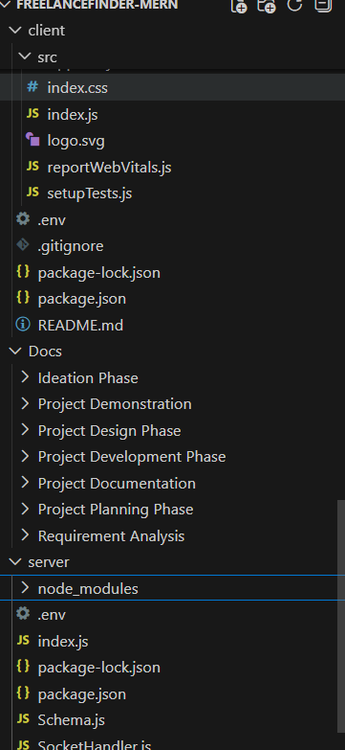
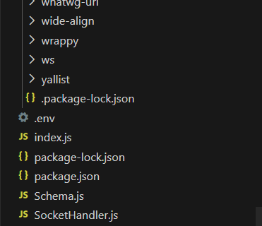
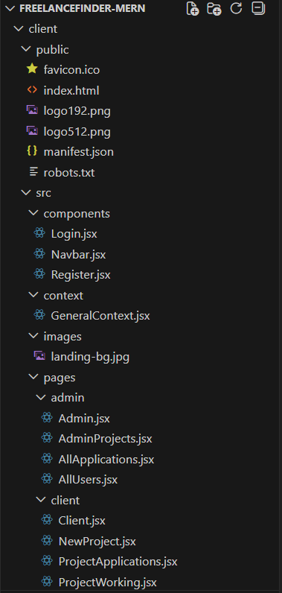

The first image is of frontend part which is showing all the files and folders that have been used in UI development

The second image is of Backend part which is showing all the files and folders that have been used in backend development

Project Flow:
Use the code in: https://github.com/KoyyalagaddaVenkataRamaRaju/freelancer
or follow the videos below for better understanding.

Milestone 1: Project setup and configuration.
- Folder setup:
- Create frontend and
- Backend folders

- Installation of required tools:

1. Open the frontend folder to install necessary tools

For frontend, we use:
    - React
    - Bootstrap
    - Material UI
    - Axios
    - Moment
    - Antd
    - mdb-react-ui-kit
    - react-bootstrap

2. Open the backend folder to install necessary tools

For backend, we use:
    - cors
    - bcryptjs
    - express
    - dotenv
    - mongoose
    - Moment
    - Multer
    - Nodemon
    - jsonwebtoken
After the installation of all the libraries, the package.json files for the frontend looks like the one mentioned below.
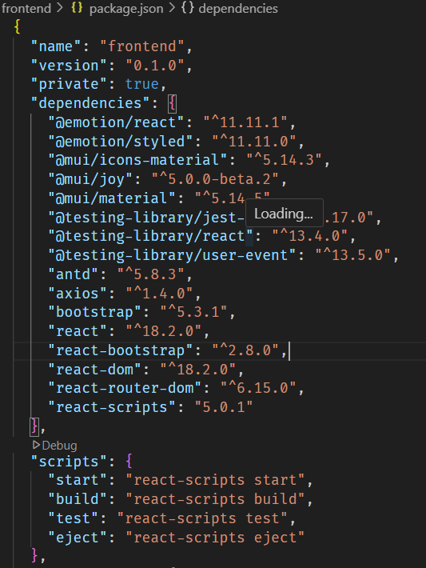
After the installation of all the libraries, the package.json files for the backend looks like the one mentioned below.
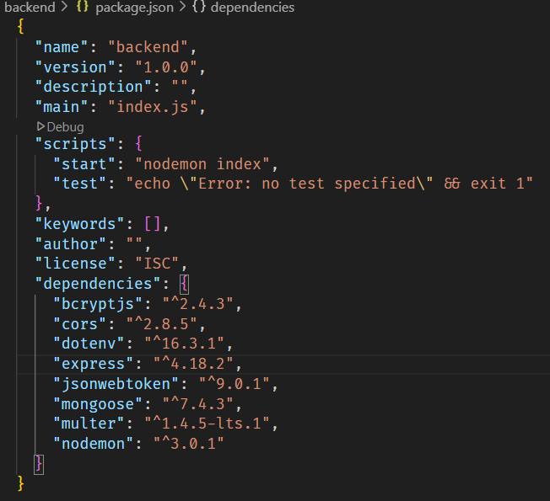

Milestone 2: Backend Development

- Setup express server
- Create index.js file in the server (backend folder).
- define port number, mongodb connection string and JWT key in env file to access it.
- Configure the server by adding cors, body-parser.

- Configure MongoDB
- Import mongoose.
- Add database connection from config.js file present in config folder
- Create a model folder to store all the DB schemas like renter, owner and booking, properties schemas.

- Add authentication: for this,
You need to make a middleware folder and in that make authMiddleware.js file for the authentication of the projects and can use it.

Milestone 3: Database Development:
- Set up a MongoDB database either locally or using a cloud-based MongoDB service like MongoDB Atlas.
- Create a database and define the necessary collections for users, transactions, stocks and orders.
- Also let’s see the detailed description for the schemas used in the database.
- For the connection of database use the code given below
- 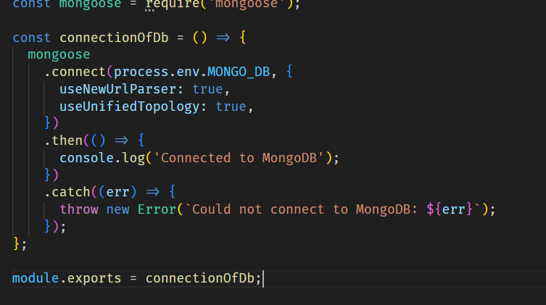

Milestone 4: Frontend Development:
- Setup React Application:
Bringing SB Stocks to life involves a three-step development process. First, a solid foundation is built using React.js. This includes creating the initial application structure, installing necessary libraries, and organizing the project files for efficient development. Next, the user interface (UI) comes to life. To start the development process for the frontend, follow the below steps.
  - Install required libraries.
  - Create the structure directories.

Design UI components:

Reusable components will be created for all the interactive elements you'll see on screen, from stock listings and charts to buttons and user profiles. Next, we'll implement a layout and styling scheme to define the overall look and feel of the application. This ensures a visually-appealing and intuitive interface. Finally, a navigation system will be integrated, allowing you to effortlessly explore different sections of SB Stocks, like viewing specific stocks or managing your virtual portfolio.

Implement frontend logic:

In the final leg of the frontend development, we'll bridge the gap between the visual interface and the underlying data. It involves the below stages.
  - Integration with API endpoints.
  - Implement data binding.

5 . Project Implementation :
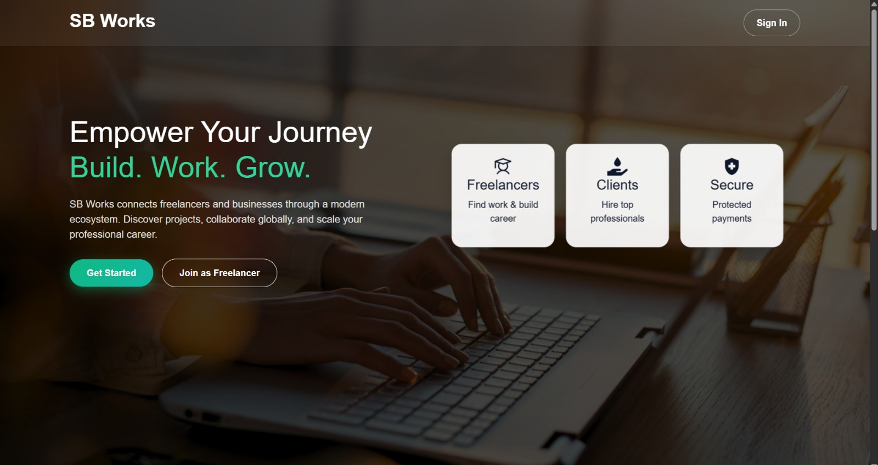

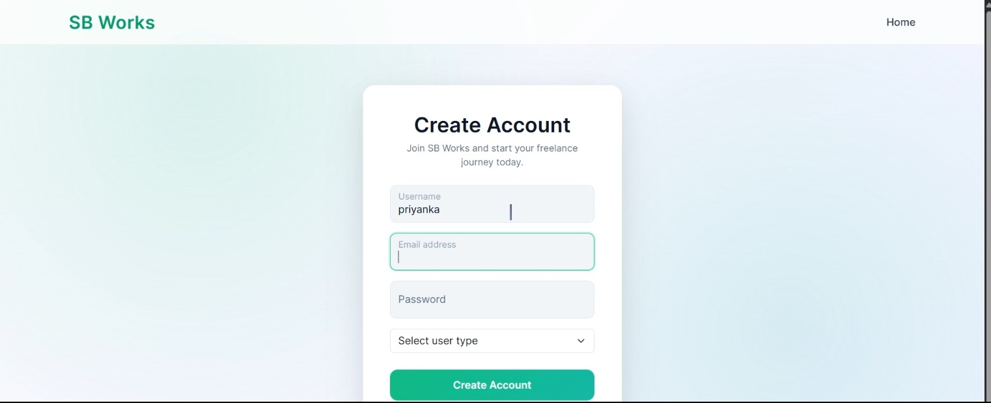

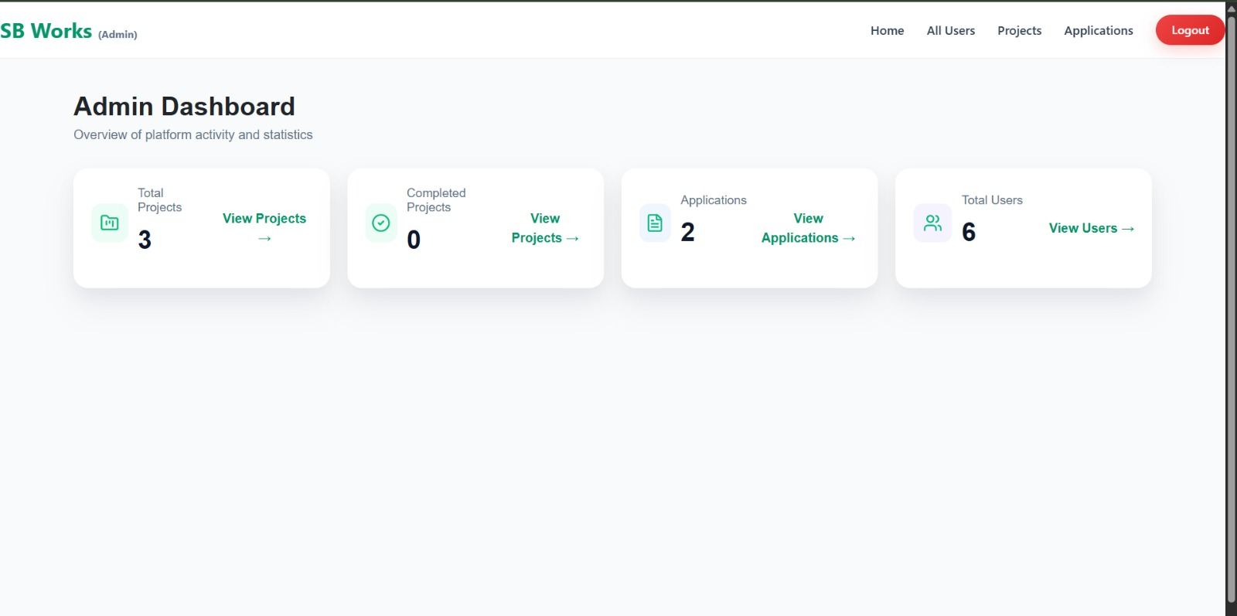

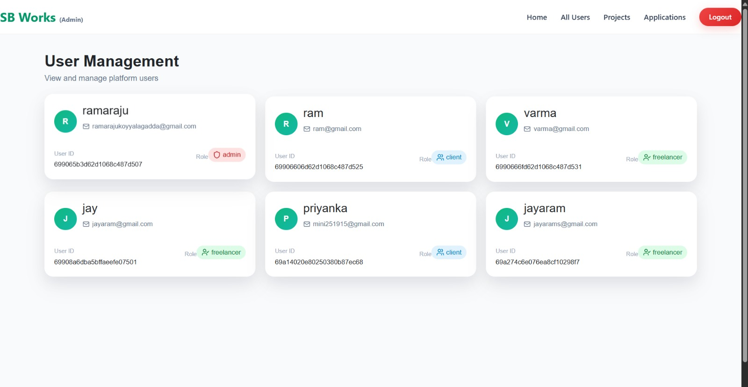
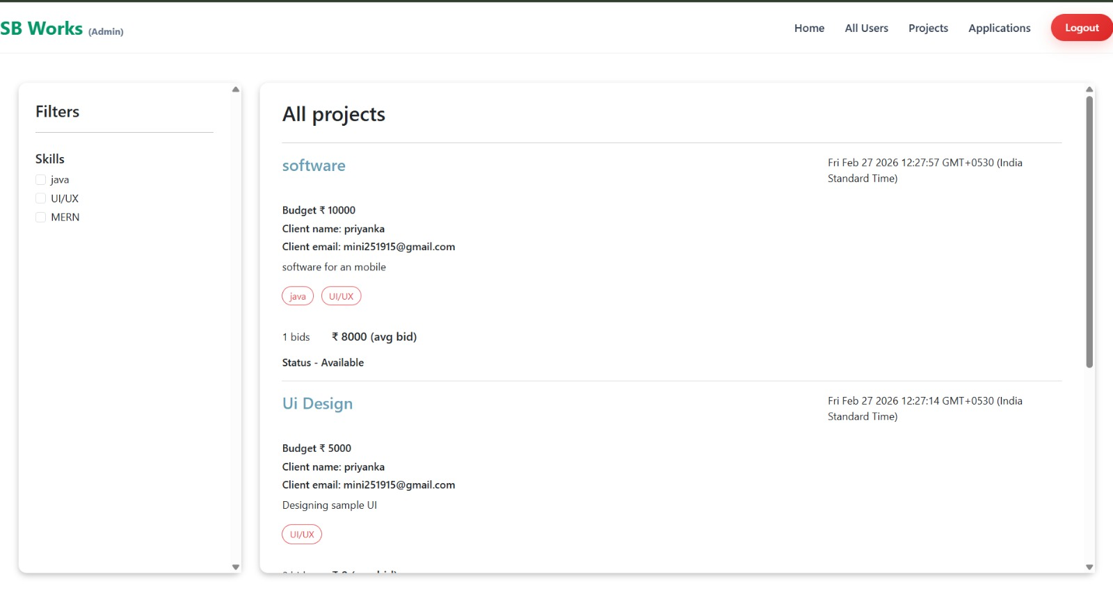

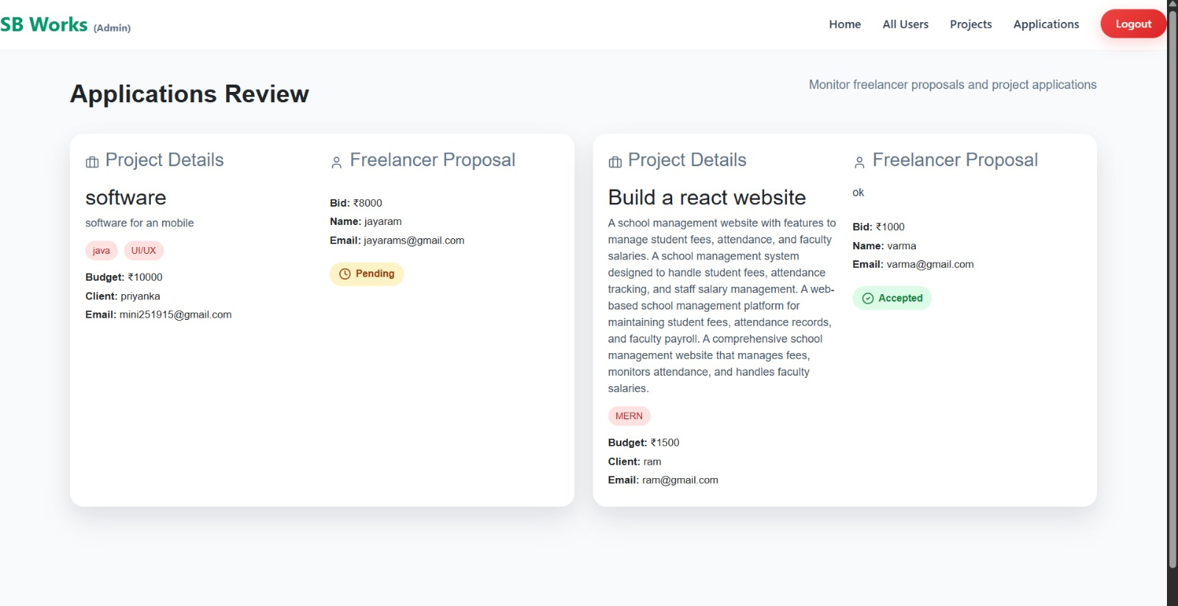

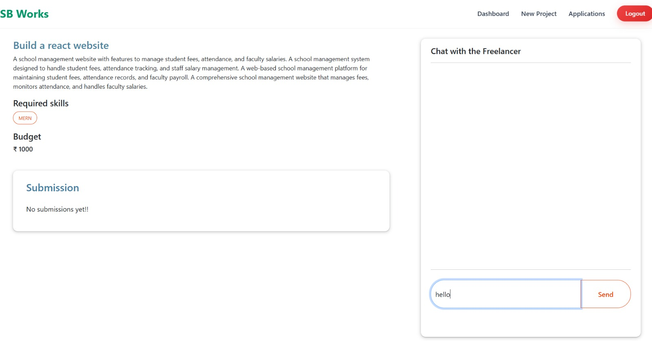

Code:
https://drive.google.com/drive/u/2/folders/1A-hYEw8Eo5i3Q0Tga-whiD5KpMacO1G_

